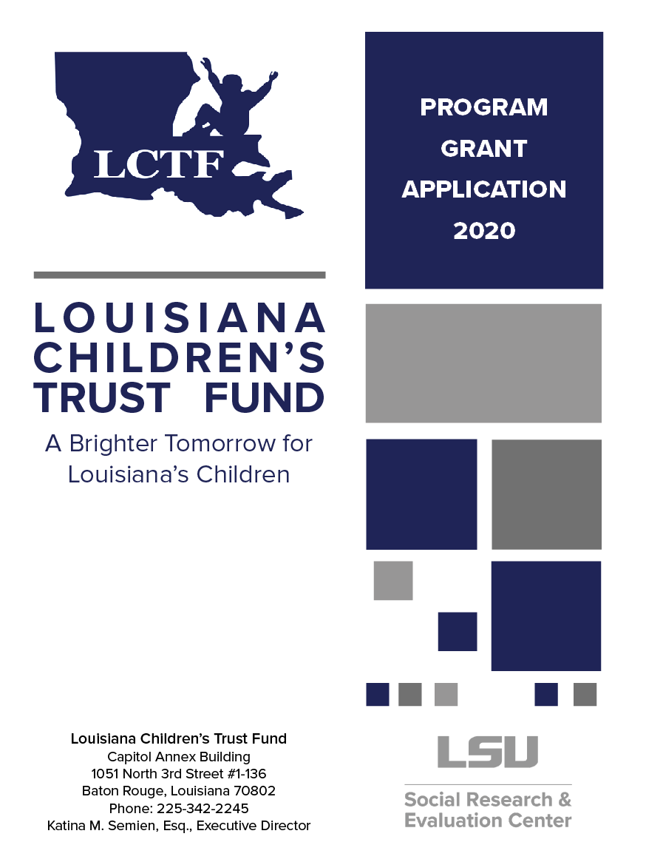

APPLICATION FORMAT REQUIREMENTS

☐ This cover page will serve as the first page of the application.
☐ Do not attach any other page(s) on top of this cover page.
☐ Proposals must be organized in the order of the titles in the application.
☐ Applicants must submit all requested information.
☐ Submit 2 originals with original signatures in Blue ink and 1 electronic copy to Michele.Rabalais@LA.GOV.
☐ Binders or other formats are not acceptable.

PLEASE CHECK TO BE SURE THAT THE FOLLOWING MATERIALS HAVE BEEN ASSEMBLED:

☐ Completed Grant Application
☐ Completed and Signed Application Signature Page (Found on Page 21)
☐ Current List of Board of Directors and Officers if applicable
☐ Two (2) Applications with Original Signatures in Blue Ink and one (1) electronic copy of the application.

public agencies must have the following:
☐ Original and Signed Letter of Authorization from organization (authorizing an individual to negotiate LCTF contract. Whoever is authorized in the letter must sign application signature page and budget pages.

non-profit agencies must have the following:
☐ Original and Signed Current Board Resolution (Board Resolution must be signed by the board president or chair and must follow the format in the grant application.) Whoever is authorized in Board Resolution must sign application signature page. Current board resolution must be signed within the last 12 months.
☐ Two Proofs of non-profit status for non-profit organizations. BOTH PROOFS ARE NEEDED:
- Letter of designation from I.R.S. AND
- Copy of charter from Secretary of State of LA or copy of Certificate to do business in Louisiana
(Full charter is not needed, just the charter page)

Note. Applications that do not have each of the required accompanying materials will be considered incomplete and will not be reviewed for funding.

☐ I certify that the above items have been completed and accompany this checklist.

APPLICATION SUBMISSION AND DEADLINE

All applications must submitted to the Louisiana Children's Trust Fund office no later than
Friday, February 28, 2020 by 4:00pm

SUBMIT BY MAIL TO*:
Louisiana Children’s Trust Fund
1051 North Third Street, #1-136
Baton Rouge, Louisiana 70802
225-342-2245 (office)
*It is advisable to send the application by certified mail or other courier which provides proof of delivery.

OR
EMAIL TO: Michele.Rabalais@LA.GOV

The Louisiana Children's Trust Fund’s Board of Directors policy is as follows:
NO LATE LCTF GRANT APPLICATIONS WILL BE ACCEPTED OR REVIEWED

UNIQUE APPLICATION CODE #
[To be completed by CTF Staff Only]

PROGRAM GRANT APPLICATION

THIS PAGE MUST BE THE FIRST PAGE OF GRANT APPLICATION

Applicant Organization | Type of Organization | Federal ID Number | Physical Address
Contact Person | Title / Position | Phone # | Email Address
Secondary Contact Person | Title / Position | Phone # | Email Address
Region(s) Program Serves  (if your program serves statewide, please enter statewide) | Parish(es) Program Serves  (if your program serves statewide, please enter statewide) | Total Amount Requested | Select one of the following which best describes the level of evidence or support for your project model:  ☐ Emerging Practice  ☐ Promising Practice  ☐ Supported Practice  ☐ Well-supported Practice
Project Name |  | LDR Number | Select one of the following which best describes your Program:  ☐ Primary—Taking measures to keep child abuse from happening  ☐ Secondary – Early  intervention measures to  prevent child  abuse and neglect
Select primary funding area(s):  ☐ Teaching children personal safety and life skills  ☐ Educational and support services for parents  ☐ Hospital and/or visitation and support services to families  ☐ Public awareness and education program for adults  ☐ Training and education of professionals and volunteers |  |  | If your program fits into another funding area, please list below.

ABSTRACT
(MUST BE LESS THAN 350 WORDS)

Abstract/Project Summary
Briefly summarize the proposed project using no more than 350 words to address each of the following points: 1) title of the program, 2) overall goals and objectives of the program, and the purpose or vision of your program in one sentence, 3) specific services that will be provided to meet the overall goals, 4) deliverables, 5) brief description of the specific population including the proposed number of individuals that will be served, 6) performance measures 7) a brief statement of how the program will aid in the prevention of child abuse/neglect, and 8) brief description of how the program is considered primary or secondary prevention.

Section 1: Problem Description and Need for Program (20 pts)

1.1 Identify social, physical, economic and/or other problems requiring an intervention. What participant needs have been identified and will be addressed by your program?

1.2 Describe the geographical area or community to be served by your event. Include relevant characteristics such as child abuse/neglect statistics, racial makeup, median income, educational attainment, and percentage of population in poverty.
1.3 Describe the needs, gaps, and services within your geographic area. What problems are faced by your target population that your program will help solve? How will your program solve these issues?

Section 2: Impact on Prevention of Child Abuse/Neglect (15 pts)

2.1 Select each protective factor that applies to your program, and state how it will be addressed.
Protective Factors | How your program will address?
☐Knowledge of parenting & child development
☐Concrete supports in times of need
☐Parental resilience
☐Nurturing and attachment
☐Social connections
☐Children's social and emotional competence

2.2 Clearly describe how the proposed program or intervention will aid in the prevention of child abuse/neglect.

Section 3: Intervention (Theory of Change) (20 pts)

A Theory of Change is the Organization’s roadmap or outline that describes how the change will be created.

3.1 Describe the proposed program. Include the specific model or curriculum, modifications to the model (if any), and the frequency of delivery.

3.2 List the proposed activities of your program.

3.3 List the expected or desired outcome(s) of your program.

3.4 List the observable measureable indicators of your program.

3.5 Using your described activities, outcomes, and indicators in 3.2, 3.3., and 3.4, develop and attach a logic model (visit the FRIENDS National Resource Center website click here for more information on logic models and click here to use logic model builder).

3.6 Provide justifications for using your described model for the specific population.

Section 4: Participation (10 pts)

4.1 From the list below, select any group(s) your program will focus on, and provide the total number proposed to be served by your program in the appropriate category.

Participants | Total Number Proposed to be Served
☐Children

☐Adults

☐Families

☐Parents

☐Professionals

4.2 Will your program focus on any of the following specific populations?

☐Children or adults with disabilities

☐Racial and ethnic minorities

☐Homeless youth or families or those at risk for homelessness

☐Adult former victims of child abuse and neglect or domestic violence

☐Fathers

☐Non-native English speakers

☐Immigrants

☐Other: Click or tap here to enter text.

4.3 Describe your recruitment and participation strategies – how will participants be recruited? What strategies will be used to retain them?

Section 5: Evaluation (15 pts)

5.1 Describe the evaluation design of your program (e.g., pre/post-test, post-test only, etc.), which shows how they will be successfully measured. Please attach a copy of the evaluation forms to be used.

5.2 Describe the data gathering methods (e.g., surveys, interviews, observations, etc.) that will be used to measure previously stated outcomes and performance indicators.

5.3 If applicable, provide the organization representative(s) responsible for data collection, analyses, and reporting results to LCTF.

5.4 Describe your organization’s capacity to collect data, enter data into a database, analyze it, compile results, and report results to LCTF. Address whether your program will collect demographic data on program participants and how it will be collected (i.e. intake form, registration form). If it is not possible to collect demographics, explain why (e.g., media campaign).

5.5 Fill out the chart below indicating the timeline for program activities and evaluation tasks.

Activities | Expected Completion Date | Responsible Party

Section 6: Organizational Capacity (10 pts)

6.1 Provide the mission statement of the organization.

6.2 Provide the evidence of the organization’s fiscal responsibility and accountability in program administration.

6.3 Attach brief job descriptions and/or biographical sketches for each key position related to the delivery of the proposed program.

6.4 Describe any additional resources that will be used for this specific program, such as supplementary funding, volunteers, in-kind support, and donations.

6.5 Will any collaborative partner(s) be involved in this program? If yes, list the collaborative partners and their roles, and provide contact information for them (key contact person, phone number, and email address).

6.6 If applicable, fill out the chart with the information about your organization’s previously funded LCTF projects.

Organization Name | Program/Event Name | Fiscal Year of the Grant | Amount of Grant Awarded

6.7 (Optional) List any relevant accreditations, certifications, and awards the organization has achieved.

6.8 Provide a brief discussion of the sustainability of your program after the LCTF funding cycle.

Section 7: Project Budget (10 pts)

Note. Please reserve requests for LCTF funds for child abuse/neglect prevention related costs. Administrative/ Indirect costs should not exceed 10% of the requested funds.

7.1 Provide a budget narrative that describes the specific costs and expenses associated with the proposed program that LCTF funds will be used to cover.
7.2 Attach detailed calculations for the specified items such as names of items, quantities, unit costs, salaries and other expenses.

BOARD RESOLUTION FOR NONPROFIT ORGANIZATION
(The Board Resolution must be current and follow the following format)

STATE OF

PARISH OF

On the |  | day of |  | 20 |  | , at a meeting of the Board of Directors of

a corporation, held in the

City of |  | Parish of

with a quorum of the directors present, the following business was conducted:

It was duly moved and seconded that the following resolution be adopted:

BE IT RESOLVED that the Board of Directors of the above corporation do hereby authorize
(name and title) and his/her successors
in office to negotiate on terms and conditions that he/she may deem advisable, a contract or contracts with the Office of the Governor, Programs and Planning, Louisiana Children’s Trust fund with the effective date of
hereby give him/her the power and authority to do all things necessary to implement,
maintain, amend or renew said documents.

The above resolution was passed by a majority of those present and voting in accordance with the by-laws and articles of incorporation.

I certify that the above and foregoing constitutes a true and correct copy of a part of the minutes of a
meeting of the Board of Directors of
held on the |  | day of |  |  | 20

Signature of the Representative | Title/Position

Board President/ Secretary/ Chair  (printed or type name) | Date

Note. Whoever is authorized in the resolution, must sign Application Assurance Signature page. Please note that the individual who affixes their signature on the Board Resolution CANNOT be the same individual who is authorized to negotiate the terms and conditions of the contract.

ASSURANCE AND SIGNATURES

THIS PAGE MUST BE COMPLETED

14.1 In addition to any other requirements imposed by the Louisiana Children's Trust Fund Board, each grant shall be subject to the condition that the applicant will comply with the following assurances:

14.1.1 The services to be provided by the applicant will be made available primarily to prevent child abuse and neglect as defined by R.S. 46:2401-2408 and policies of the Children's Trust Fund Board.

14.1.2 Neither in the selection, compensation, or other employment practices nor in all portions and services of the entire program of which, or in connection with which, aid is sought shall there be any discrimination because of race, creed, color, sex, national origin, or physical or mental impairments in accordance with Title VI of the Civil Rights Act of 1964 (P.L. 88-352 and Section 106 of P.L. 90-170 as amended.)

14.1.3 Any building used in connection with the delivery of services by the applicant shall meet standards adopted pursuant to the Architectural Barriers Act of 1968 (P.L. 91-480).

14.1.4 The applicant shall comply with, and make the necessary arrangements for, a grievance procedure for clients as provided by the Louisiana Children's Trust Fund. (Grievance procedures are enclosed in packet.)

14.1.5 Grantee shall respect all legal and human rights of clients and potential clients as protected by relevant federal and state laws and regulations.

14.1.6 From the date a grant is awarded on the basis of this application, the applicant will take all actions reasonably necessary to initiate all services described in this application with respect to which the award provides assistance, which actions are expected by the applicant to permit the initiation of such services from:

Beginning Date
Ending Date

14.1.7 The program/facility will be maintained and operated in accordance with minimum standards prescribed by the appropriate State authority for the maintenance and operation of such program/facility.

14.1.8 The applicant will maintain adequate and separate accounting and fiscal records and accounts for all funds provided from any source to pay the cost of the project and permit audit of such records and accounts at any reasonable time by representatives of the Department of Children and Family Services and the State of Louisiana.

14.1.9 No funds received under the Louisiana Children's Trust Fund may be used to lobby for legislation on the federal or state level.

ASSURANCE AND SIGNATURES

THIS PAGE MUST BE SIGNED AND COMPLETED

14.2 This assurance is given in consideration of and for the purpose of obtaining a grant under R.S. 2401-2408 extended after the date hereof to the applicant. The applicant recognizes and agrees that such financial assistance will be extended in reliance on the representations and agreements made in this assurance. The assurance is binding on the applicant, its successors, transferees, and assignees.

14.3 The applicant accepts, as to any grant awarded, the obligation to comply with regulations in effect at the time of the award.

14.4 The applicant requests that payments be made and forwarded to:
(Please type or print all information in this section.)

14.4.1 Name
14.4.2.Title
14.4.3 Address
14.4.4 City |  | State |  | Zip
14.4.5 Telephone | ( ) | Ext.

14.5 The undersigned hereby certifies that the statements made in this application are correct to the best of its knowledge and belief that all assurances contained in this section will be adhered to, and is authorized to sign this application on behalf of the applicant.

14.5.1 Date
14.5.2 Legal Name of Applicant

14.5.3 Signature of Responsible Officer
14.5.4 Title of Responsible Officer

14.5.5 Address of Responsible Officer
Street Address
City |  |  | State |  | Zip

